**DAILY ONLINE ACTIVITIES SUMMARY**

|  |  |  |  |  |  |  |
| --- | --- | --- | --- | --- | --- | --- |
| **Date:** | **27/05/2020** | | | **Name:** | **JASLINE SHARON TAURO** | |
| **Sem & Sec** | **4th sem, A Section** | | | **USN:** | **4AL18CS029** | |
| **Online Test Summary** | | | | | | |
| **Subject** | | **OBJECT ORIENTED CONCEPTS** | | | | |
| **Max. Marks** | | **30** | | **Score** | **25** | |
| **Certification Course Summary** | | | | | | |
| **Course** | **1.Introduction to IoT 2.Introduction to Packet Tracer** | | | | | |
| **Certificate Provider** | | | **CISCO ACADEMY** | **Duration:** | | **4 hrs.** |
| **Coding Challenges** | | | | | | |
| **Problem Statement: 1. Write a C Program to sort an array of integers in ascending order and display the sorted array and Number of passes performed for sorting**  2.  Given an array arr [] of the positive integers of size N, the task is to find the largest element on the left side of each index which is smaller than the element presents at that index. | | | | | | |
| **Status: DONE** | | | | | | |
| **Uploaded the report in GitHub** | | | | **YES** | | |
| **If yes Repository name** | | | | [**https://github.com/jaslinesharontauro/C_Prgms**](https://github.com/jaslinesharontauro/C_Prgms) | | |
| **Uploaded the report in slack** | | | | **YES** | | |

**Online Test Details: (Attach the snapshot and briefly write the report for the same)**

**Certification Course Details: (Attach the snapshot and briefly write the report for the same)**

**Coding Challenges Details: (Attach the snapshot and briefly write the report for the same)**

**1.ONLINE TEST DETAILS:**

**Today we had assessment in the subject OBJECT-ORIENTED CONCEPTS it was based on second module of this subject. There were total 30 number of questions of ONE mark each.**

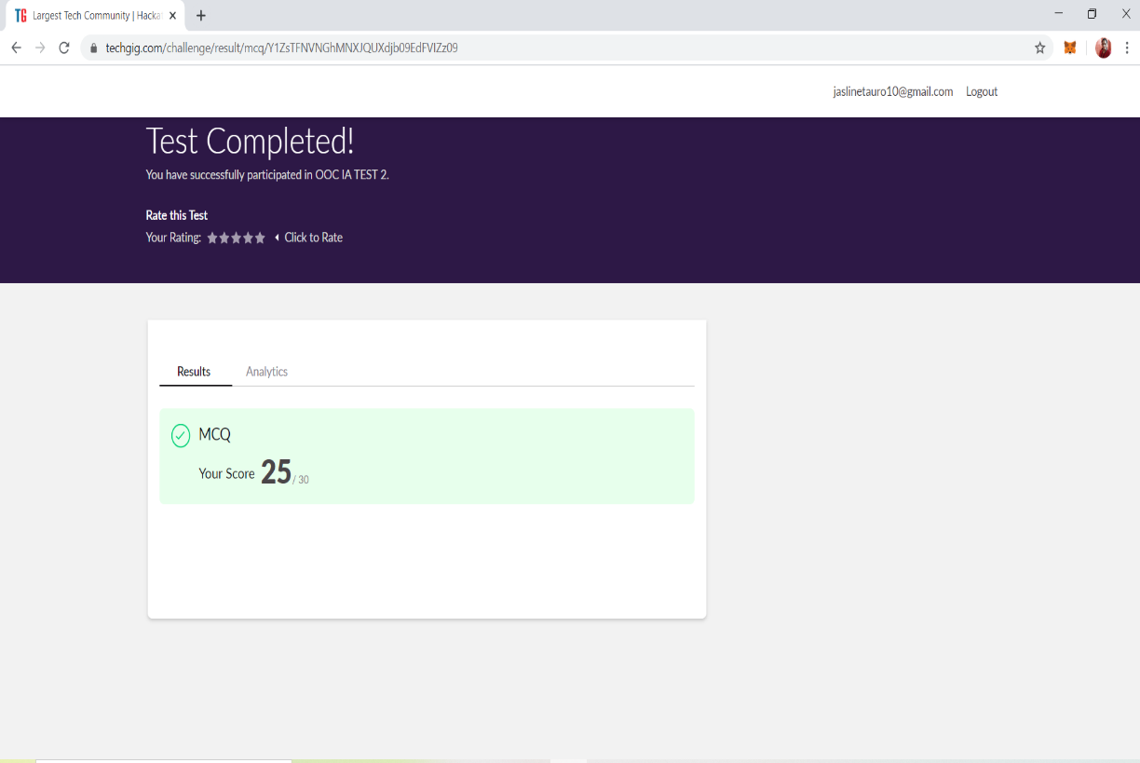

**2.CERTIFICATION COURSE DETAILS**

**1.Today I have done certification course on INTRODUCTION TO IoT By CISCO NETWORKING ACADEMY.** This Introduction to Internet of Things 2.0 course is designed for people wishing to explore the Internet of Things and the impact it has on our everyday lives. It is not the intention of this course to teach about the IoT in depth but to provide a general understanding of the IoT and how it allows for digitization of daily tasks.



3.Today I have done certification course on INTRODUCTION TO PACKET TRACER by CISCO NETWORKING ACADEMY. This Introduction to Packet Tracer course is designed for new users of Packet Tracer for self-study and familiarization with the tool used in many Networking Academy courses. It is not the intention of this course to teach networking and IoT technology.

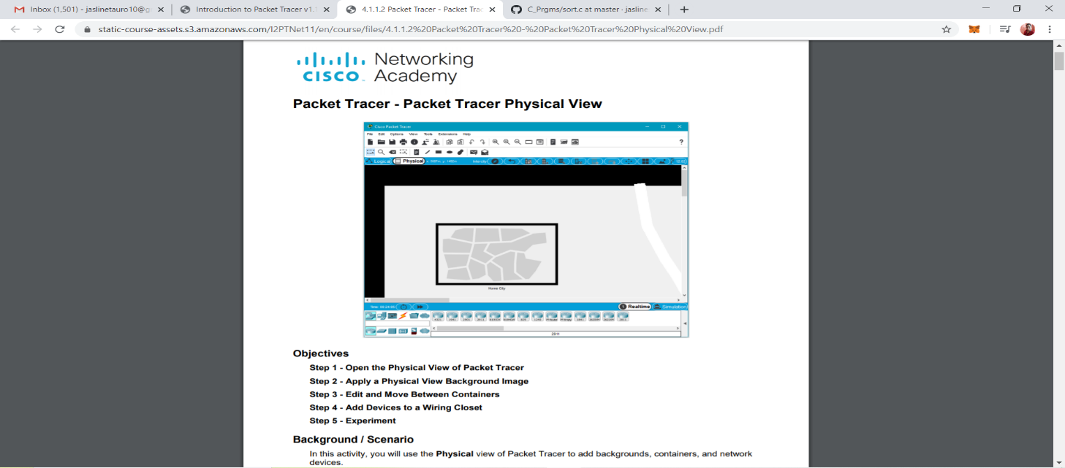

**3.CODING CHALLENGES DETAILS:**

**Problem statement 1:**

[In Bubble sort, each pass consists of comparison each element in the file with its successor (i.e. x[i] with x[i+1]) and interchanging two elements if they are not in the proper order. The array may be sorted in any pass. If the array is sorted, then remaining passes should be skipped off. Write a C Program to sort an array of integers in ascending order and display the sorted array and Number of passes performed for sorting.](https://github.com/orgs/alvas-education-foundation/teams/2nd-year/discussions/83)

|  |
| --- |
| In Bubble sort, each pass consists of comparison each element in the file with its successor (i.e. x[i] with x[i+1]) and interchanging two elements if they are not in the proper order. The array may be sorted in any pass. If the array is sorted, then remaining passes should be skipped off. Write a C Program to sort an array of integers in ascending order and display the sorted array and Number of passes performed for sorting. |

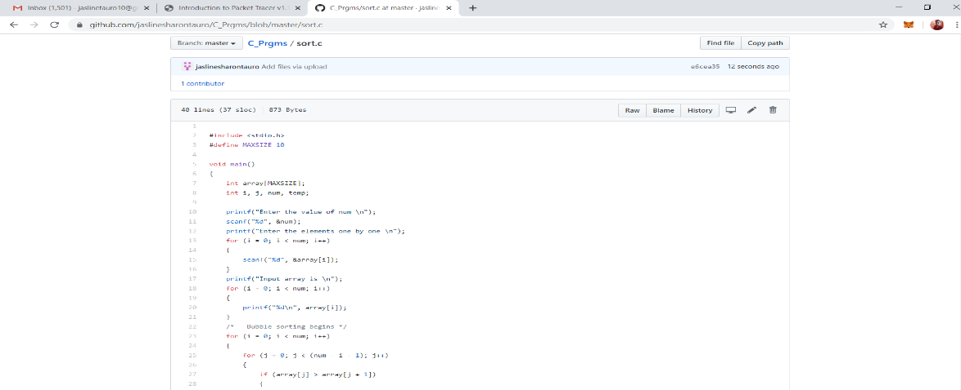

**Solution: Uploaded it in GitHub**

**Problem Statement 2:**

Given an array arr [] of the positive integers of size N, the task is to find the largest element on the left side of each index which is smaller than the element present at that index. Note: If no such element is found then print -1.

Input: arr[] = {2, 5, 10}  
Output: -1 2 5  
Explanation :  
Index 0: There are no elements before it  
So Print -1 for the index 0  
Index 1: Elements less than before index 1 are – {2}  
Maximum of those elements is 2  
Index 2: Elements less than before index 2 are – {2, 5}  
Maximum of those elements is 5

Input: arr[] = {4, 7, 6, 8, 5}  
Output: -1 4 4 7 4  
Explanation :  
Index 0: There are no elements before it  
So Print -1 for the index 0  
Index 1: Elements less than before index 1 are – {4}  
Maximum of those elements is 4  
Index 2: Elements less than before index 2 are – {4}  
Maximum of those elements is 4  
Index 3: Elements less than before index 3 are – {4, 7, 6}  
Maximum of those elements is 7  
Index 4: Elements less than before index 4 are – {4}  
Maximum of those elements is 4

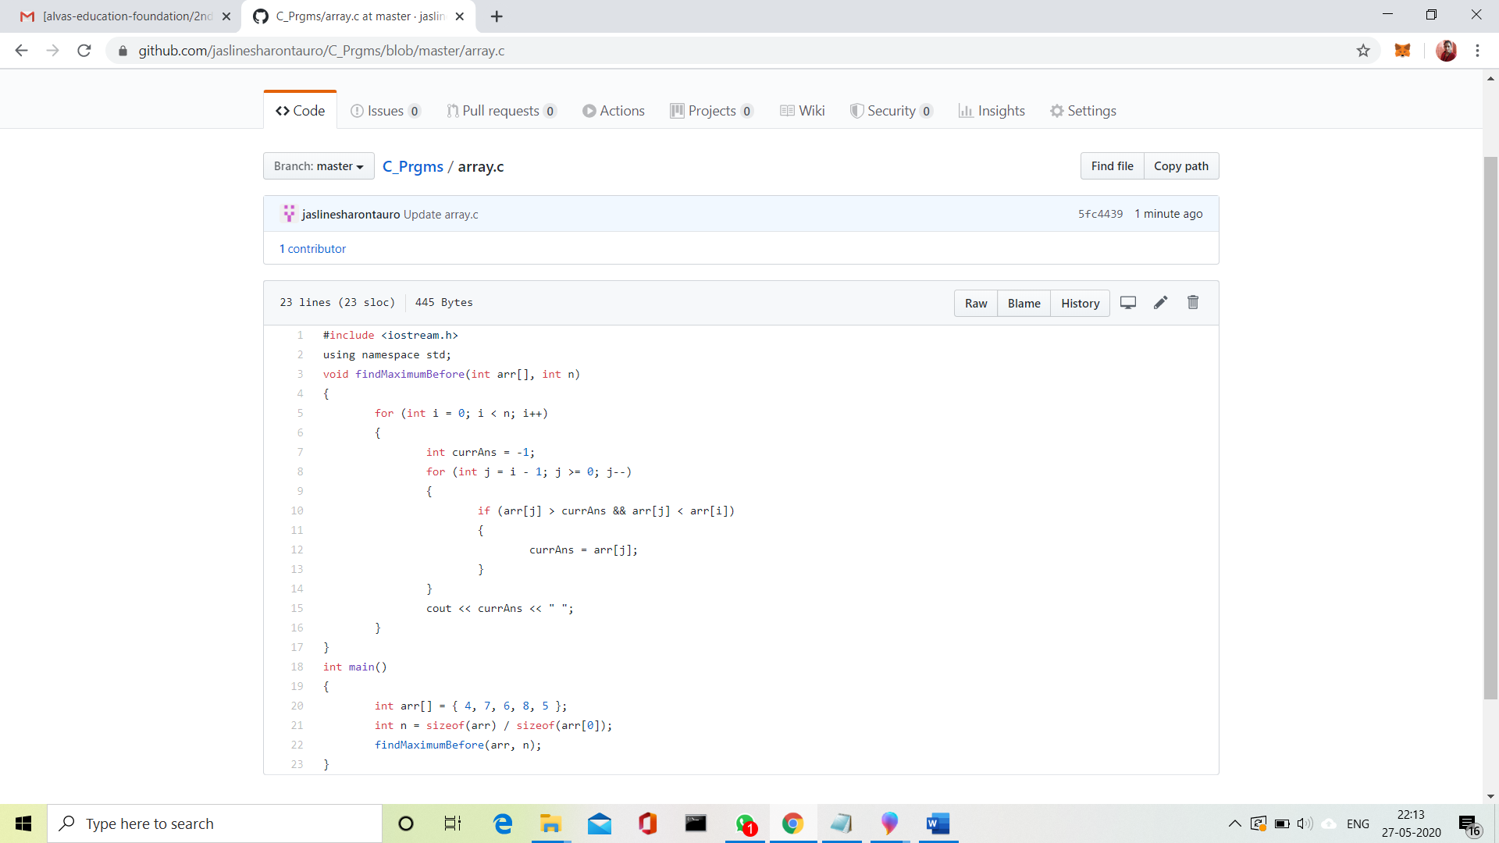

**Solution: Uploaded it in GitHub**